This phonics book belongs to

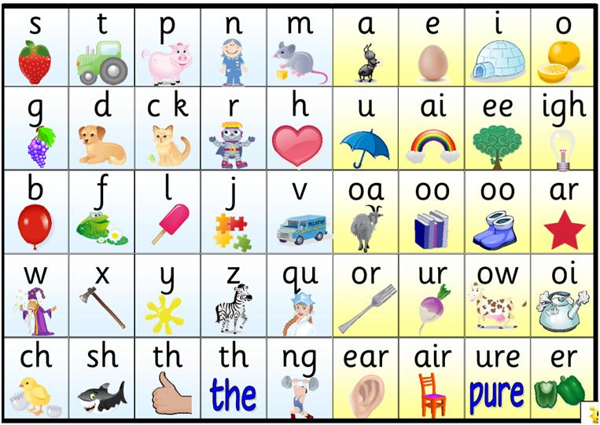

ch

sh

th

Can you write a sentence using these qu and ng words?
queen quilt square quick

sing long sting king

Can you draw a picture for these words?
ring | thunder | chips
shop | quack | shell
Trace over these graphemes. Can you guess the sound?
ai ay
a-e eigh
ey

Here are the different ai graphemes…
ai ay a-e eigh
Tick the ones you know
Can you match the word to the picture?
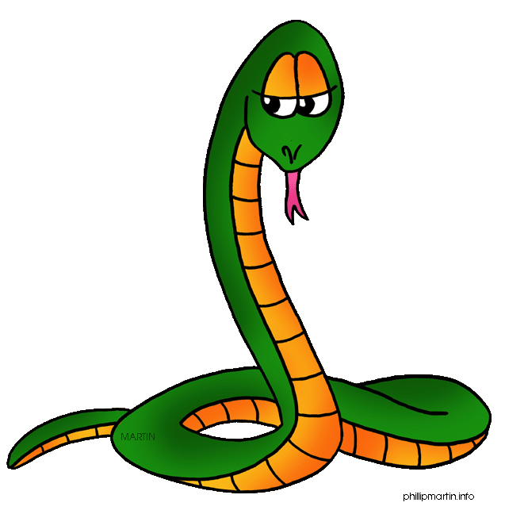
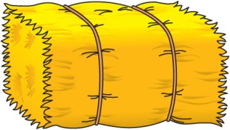
chain
eight
hay
train
spray
snake
cake
Can you read this phoneme spotter and highlight all of the ai graphemes? The first sentence has been done for you.
ai ay a-e eigh ey
The School Sale
It was the day of the school sale. Mum could not go as she had a pain in her knee, so Gran said she would take Kate and Wayne. They could not wait!
At the school gate, Gran paid 20p to get in. She did not have to pay for Kate and Wayne – it was free for children!
As soon as they were through the gate, Gran gave Wayne and Kate £1 each to spend, and told them not to go too far away.
The sun was shining. “It’s as hot as Spain!” said Gran. “I think I need a cup of tea.”
At the tea stall, a lady put Gran’s tea on a tray, and Gran went to find a place to sit in the shade.
Meanwhile, Kate and Wayne went round the stalls. Kate had her face painted like a rainbow and had a go on the “Name a Teddy” stall. Wayne bought a game of chess and a piece of chocolate cake for Mum. They both had a go on the “Pin the tail on the donkey”. It was quite safe – the donkey was only made of paper!
When the sale was nearly over, Kate and Wayne went back and found Gran fast asleep under the tree. “What a shame,” said Kate, “she missed all the fun!”
Trace over these graphemes. Can you guess the sound?
ee ea
e-e
ey ei y
Here are the different ee graphemes…
ee ea e-e
ey ei y
Tick the ones you know
Can you circle the right word for each picture?
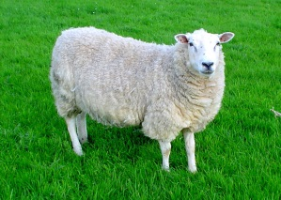 | 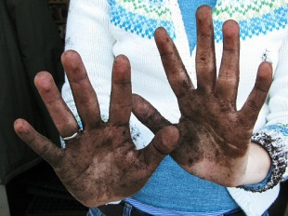
sheep sheet | clean dirty | please peas
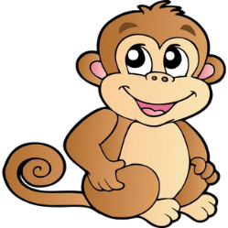
monkey jockey | foot feet | meat sweets
sweep swede | tea coffee | monkey money

Can you read these mini stories and highlight all of the ee graphemes?
ee ea e-e
ey ei y

A thief went to steal the queen’s green beads. As she went up the honey tree a buzzy bee stung her. ‘Ouch, that feels funny,’ and she screeched like a monkey.

Pete the sheep is at a big meal called a feast. He eats some peas and green beans. Then a beast sneaks up and steals a peach and says, ‘I want some meat!’ ‘Please don’t eat us’, shrieked the sheep. Pete woke up with a scream and said, ‘Silly me I was asleep and it was just a dream! That makes me happy!’
Trace over these graphemes. Can you guess the sound?
igh ie
i-e
y i
Here are the different igh graphemes…
igh ie i-e
y i
Tick the ones you know.
Read the words and decide if they are they trash or treasure. Draw a line to the correct picture.
kind
high
smile

clite
pie

flighk
shripe
my
bike
blien
tie
chibes
kite
Can you highlight all the igh words in this phoneme spotter?
igh ie i-e y i
A Right Mess
The twins’ bedroom was a right mess! Mum had tried everything. Being cross! Being kind! But it just did not help. The twins still did not tidy their room.
Then Mum had an idea. “I think I’ll write a list of things the twins must pick up, and then we can play a game of hide and seek. The twins must find the things and put them in a box. Their room will be tidy!”
This is the list Mum had:
A crisp bag
A white sock
A tie with a stripe
A plastic knife
A bright red kite
“We like this game of hide and seek,” said the twins. In no time at all the room was quite tidy and Mum was happy.
Then the twins had an idea. “Mum, we’d like to fly this kite on the green.”
“All right,” said Mum, “but you must hold the string tight.”
On the green there was a light breeze and the kite went up, up, up, high in the sky. Then suddenly it came down, down, down…
CRASH! It fell into the duck pond!
The kite was fine, but Mum said, “I think it’s time for tea. Let’s go home.”
Trace over these graphemes. Can you guess the sound?
oa oe
o-e ow
o
Here are the different oa graphemes…
oa oe o-e
ow o
Tick the ones you know.
Circle the pictures which have an oa sound

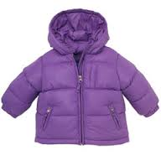 | 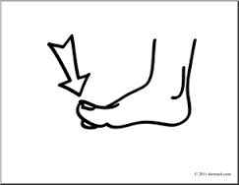
 |  | 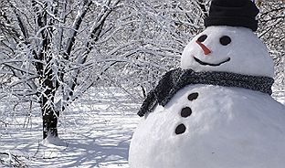
 |  | 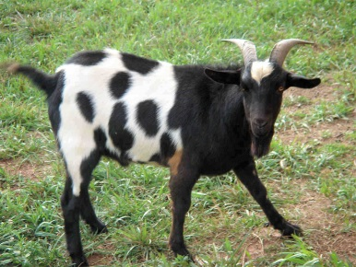

Can you draw a picture to match these words? Draw an alien for the made up words!
glopes | boat
home | blow
shome | prokes
cone | whoze
Can you highlight all the oa words in this phoneme spotter?
oa oe o-e
ow o
Joan the Goat
Once there was a goat called Joan. She had a yellow boat and she wanted to float on a moat. She went to the moat but then came some snow. Joan went back home. She got on the phone to her friend Crow and moaned, “It has begun to snow when I want to float in my yellow boat on the moat!”

Crow told her to wait for the snow to melt and flow away. So Joan waited until the next day when the yellow sun came. The snow began to melt into water, and then it flowed into the moat.

Joan put her yellow boat on the moat and it floated. She told Crow to follow. So Joan and Crow had a lovely float on the moat. After that they went home to eat some stone soup.
Trace over this grapheme. Can you remember the two sounds it makes?
oo
The oo grapheme makes two slightly different phonemes.
Can you match the words to the pictures?
boot
look
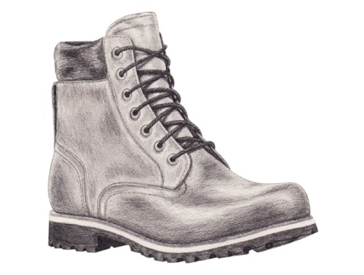
moon
book
spoon

Can you read the words can decide if they make the long oo sound or the short u sound? The first two have been done for you
shoot look moon book spoon foot mood good
hood soon zoo tool broom

long oo | short u
shoot | look
Trace over this grapheme. Can you remember the sound it makes?
ar

Read these ar words and use them to fill in the blank spaces
car star card cart sharp March party

- At night I can spot a _____ in the sky.
- You must not touch a saw, they are ______.
- I am going to send my new friend a ____.
- When I am older I want to drive a ____.
- My Birthday is in _____.
- When I am six I want to throw a _____.
- A trolley is sometimes called a shopping ____.
This is the Mr Ar and Mrs Ar. They need your help to name their alien children. They only want names which use an ar sound. Circle the names they could use.
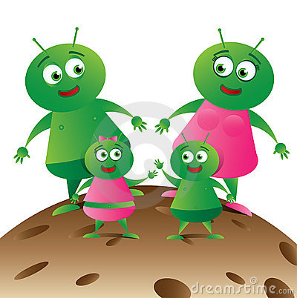

Sarp | Florps | Moog
Shrar | Larvt | Crarm
Groibs | Clarb | Scards
Blarts | Droik | Flarn

Trace over these graphemes. Can you guess the sound the all make?
or aw
au al
our
Here are the different or graphemes…
or aw au
al our
Circle the correct or word
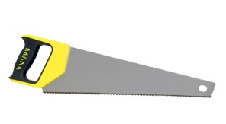 | 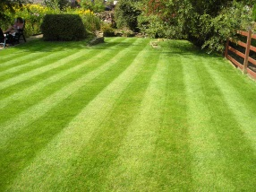
saw tool sharp | grass lawn cut | mouth yawn
 |  | 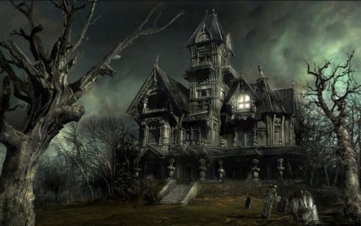
born baby new | number four | house haunt
draw chalk | corn food yellow | pour milk drink

How many or graphemes can you highlight?
or au aw al our
Paul Corn is an author who writes short stories for children. He was born in Dorset and has four daughters and four sons.
He is writing his fourth book about a dog who can talk. The dog, called Stalk, begins to talk after being caught in a storm. His owner finds him lying on the lawn with his feet up in the air and his tongue hanging out of his jaw. Fearing the worst they take Stalk to the vet, Mr Shawl, who looks the dog and is amazed when Stalk makes a magical recovery!
After a day at the vets Stalk is able to walk home and is able to move his jaw to talk!
The book will be launched in August and will feature all of Stalk’s claw and paw adventures!
If you or your family would like to meet Mr Corn he will be in England doing a book tour to promote his new book.
saw | paw | raw | claw | jaw
lawn | yawn | law | shawl | drawer

a | c | r | o | w | w | g | y | u | p | l
I | s | v | n | h | s | h | a | w | l | d
u | a | y | a | c | k | l | w | c | a | s
q | w | b | e | l | a | w | n | b | w | q
e | t | h | d | a | s | s | z | x | m | r
x | d | r | a | w | e | r | i | j | l | l
s | f | a | e | r | h | s | r | h | a | b
p | a | w | l | p | t | r | j | g | f | w

Trace over these graphemes. Can you guess the sound the all make?
ur er
ir

Draw a picture of the ur/er/ir word in each silly sentence
A frog has fur on its tummy.
The farmer caught a chicken in her hat.
Dirt on your skirt is scary.
A bird has five wings.
The third teacher is blue.
Only turn if you eat slime.
My shirt came first.

How many ur graphemes can you find? Do you notice any more?
ur er ir ear
Mr Burn’s bad day
Mr Burn, the worm, turned over one bright Sunday morning to see a bird perching on a fern bush outside his window. He heard it singing and saying words in its own bird language. “What a super day it will be”, he thought. But he was wrong!
He got up and put some toast in the toaster. Whilst he waited he melted the butter. He could smell something funny…”oh no!” he shouted, “The toast is burnt!” he put out the small fire that had started and then realised he was late for church.
He got to work as quickly as his body would carry him. He was nervous as he went through the door in case Miss Turd told him off. She did and she made him cry and told him that he had to stay after work to do some extra learning.
To cheer himself up he went surfing. It all started off well and he was riding some great waves, but suddenly a huge one came along and crashed down on his fury body. The next thing he knew he was in a hospital bed with a nurse by him. She told him that he had lost his whole body so they’d had to replace his body with someone else’s in an operation. When he looked down he was no longer a good looking worm but just a worms head on the top of a curly caterpillar’s body. “This is the worst day in the world” he said. The end.
Trace over these graphemes. Can you remember the sound they make?
ow ou

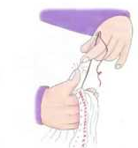
This is a doctor who turns letters into ow words.
When the letters go into the machine they come out as words. Can you write what the words will be? Remember ow is usually at the end of a word and ou is in the middle.
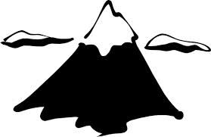
m _______
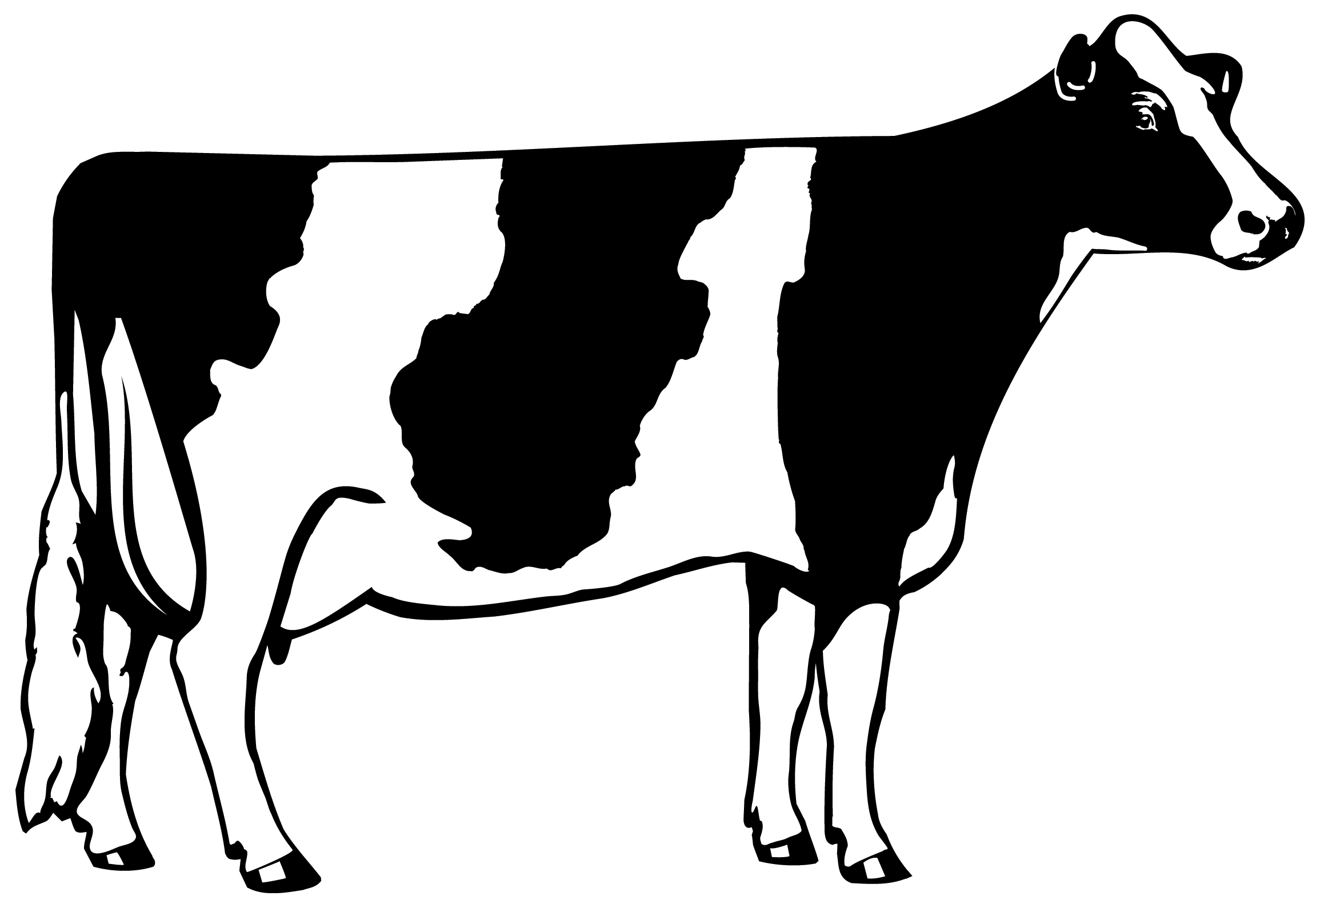
c ___

c_______
m_____

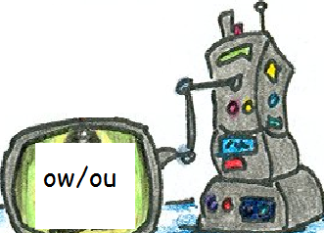
c_______

Can you highlight the ow/ou graphemes in these sentences?
Don't frown, wear this crown!
Don't row and shout, sit down and talk.
How now, brown cow?
I don't doubt that you have a cold; there is a bout of it going around.
He gave him a clout about the head.
The Boy Scout was hiding, not making a sound. He didn’t want to be found.
She was proud of her voice and sung loudly, but she did not shout.
Can you write your own sentence using an ow/ou word?

Trace over these graphemes. Can you remember the sound they make?
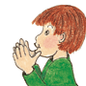
oi oy

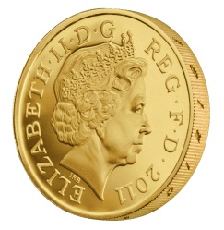
Can you read these oi/oy words and draw and match them to the picture? If the word isn’t real then it could be an alien name!
boil
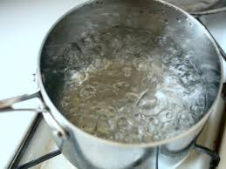
toys
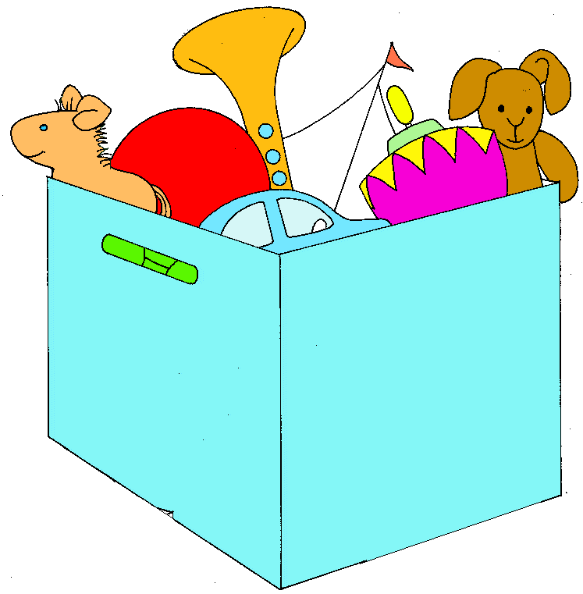
coin
oink
royal
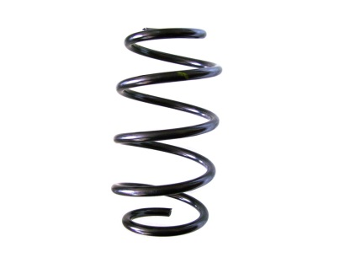
boy
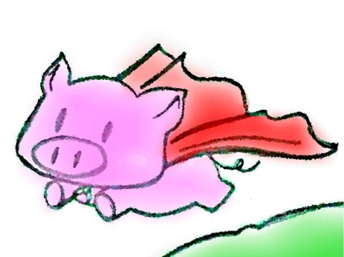
coil
shroy
Read the silly sentence and highlight the oi/oy words.

Roy took a fury toy to a slimy boy.

The royal pig went oink in the soil.

Boil a coin and it will turn into a boy.

Do not annoy the foil coil.

Trace over this grapheme. Can you remember the sound it makes?
ear

Can you find these ear words in the crossword?
hear clear gear
dear tear smear
year fear near
h | s | a | f | b | n | c | z
e | m | c | e | d | e | a | r
a | e | l | a | s | a | y | d
r | a | e | r | e | r | v | n
t | r | a | h | t | e | a | r
y | s | r | n | v | b | c | w
u | d | f | g | g | e | a | r
i | y | e | a | r | x | z | t

Look, cover, write, check
hear ________ fear___________
clear ________ tear ___________
year ________ dear ___________
Trace over this grapheme. Can you remember the sound it makes?
air
are

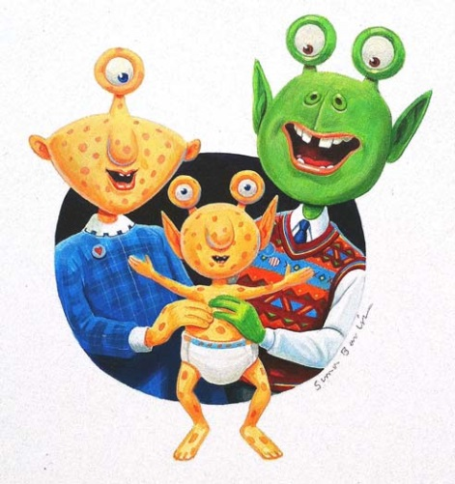
Mr and Mrs Real like real words and Mr and Mrs Alien like made up words. Can you sort the words and give them to the right families?
hair
share
slairs
frair
fair
stair
glare
flare
nair
drairs
chair

Trace over these graphemes. Can you remember the sound they make?
ew ue
u-e
Create a pattern by…
Colouring ew yellow
Colouring ue blue
Coloruing the split digraph u-e red

new | cube | few | flu-te
true | clue | blue | glue
tube | dew | cute | screw

Read the story and listen for the ew sound. Can you highlight all of the ew/ue/u-e graphemes?

Luke and Ruth
It was Saturday and Luke went to play at Ruth’s house. Ruth and her mum had the house next to Luke and his family. ‘Let’s go outside,’ said Ruth as she put her blue boots on, ‘Do you need boots too?’ ‘I do. I’ll nip home and take my new shoes off,’ said Luke, ‘I’ll be back soon.’ Luke came back and the two of them began to dig. ‘Can I use the spade?’ said Luke. ‘Yes. Can you help me move this big root?’ said Ruth, ‘Then we can sow the seeds.’ Luke and Ruth soon had the seeds in the ground and they made the earth smooth on top. ‘Now we will wait until they grow,’ they said.
Two weeks later, Ruth ran to Luke’s house. Quick! The seeds are growing.’ Luke ran round to see if it was true. It was. In the next few weeks they grew and grew and, in June, they had blue flowers. ‘Our blue flowers are super,’ said Luke. ‘The best,’ said Ruth.
Put the words in the correct place.
flew drew chew stew
1. Dogs like to _____ on bones.
2. The bluebird _____to the oak
tree.
3. Sue _____a small, black cat.
4. We had beef _____for supper.
Put the words in the correct place.
cure tune tube cute

1. June can play a _____on the flute.
2. The vet will _____the sick mule.
3. Luke has a _____little puppy.
4. Sue was rude to her teacher.
5. Use this _____of toothpaste.

Put the words in the correct place.
glue blue clue rescue
1. Sue will wear her _____dress to the party.
2. Please do not spill the _____!
3. This footprint is a _____.
4. The sky is _____today.
5. Who will _____the lost puppy?

Now write your own sentences using
ew ue u-e
- _______________________________

- _______________________________

- _______________________________

Trace over these graphemes. Can you remember the different sounds they make?
wh
ph
Read the caption and draw a picture to match.
The whale spoke to his friend on his phone.

Pete the dolphin had a white wheel for a bed.
The mouse had three whiskers and spoke in a whisper.

Which whistle would you like?

